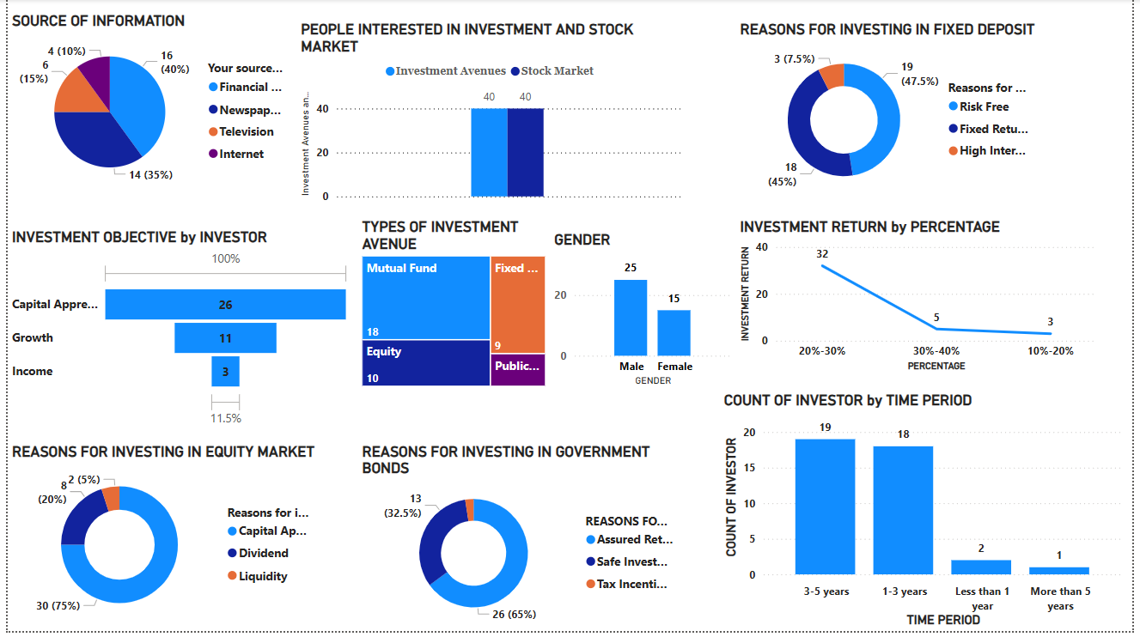

**FINANCE DATA ANALYSIS**

**INTRODUCTION**

Investment methods offer various strategies for growing wealth, managing risk, and achieving financial goals. Understanding these methods helps investors make informed decisions that align with their objectives, risk tolerance, and time horizon.

**SWOT ANALYSIS**

**WEAKNESS**

* Volatility
* High Fees
* Complexity

**STRENGTH**

* High Potential Returns
* Strong Fundamentals
* Liquidity

**THREATS**

* Economic Downturn
* Market Competition
* Geopolitical Risks

**OPPORTUNITIES**

* Market Trends
* Expansion Potential
* Innovation

**FROM THE DATA GIVEN**

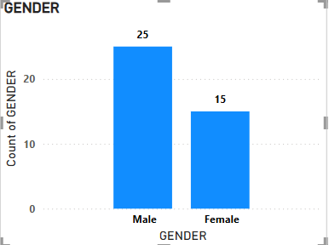

**From the analysis, it came to know that 25 percent of Male and 15 percent of Female are interested in investment**

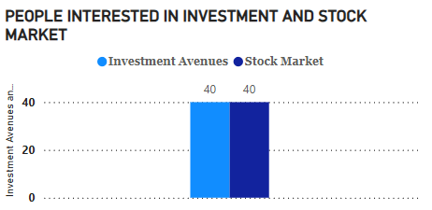

**From this bar chart it shows that 40% of people are interested in avenues investment and 40% of people interested in stock market investment.**

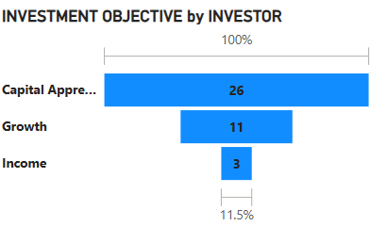

**From this Tunnel chart e came to know that people are interested to invest in financial methods**

* **26% of people are investing for their Capital appreciation**
* **11% of people are investing for their Growth**
* **3% of people are investing for their income.**

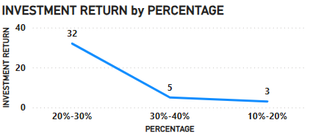

**This line chart shows the People expectation of money returns in percentage**

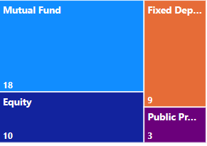

**This Tree map chart shows the interest of people in different kinds of investment methods**

* **18% of people are investing in Mutual funds**
* **10% of people are investing in Equity**
* **9% of people are investing in Fixed deposit**
* **3% of people are investing in Public Provident Fund**

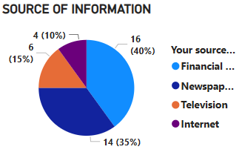

**This Pie chart shows how people are getting financial information**

* **40% of information through financial consultants**
* **35% of information through Newspaper**
* **15% of information through Television**
* **10% of information through Internet**

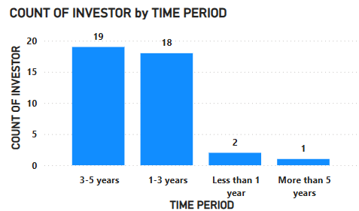

**According to this bar graph, the greatest number of people who are willing to invest is three to five years, and the minimum number of people who are willing to invest is more than five years, which is a lengthy time period.**

**FINDINGS:**

**I learned from this data analysis dashboard that more people—male and female—across all age groups are interested in investing, with mutual funds drawing their attention because of their relatively low risk and high return. All those information are getting through financial consultants like agents. And ready to invest in long term period.**

**RECOMMENDATION:**

* **Decide whether to invest in equity, debt, a partnership, or another financial instrument.**
* **Determine the appropriate amount of capital to invest based on analysis and risk tolerance.**
* **Identify optimal entry points (e.g., price levels, timing) and define exit strategies (e.g., selling criteria, time horizon).**
* **Identify risks related to operations, supply chain, or technology**
* **Review financial statements, including income statements, balance sheets, and cash flow statements.**

**CONCLUSION:**

**Each investment method has its own set of advantages, risks, and strategies. By understanding these methods, investors can tailor their investment approach to fit their individual needs and financial goals, ultimately leading to more informed and effective investment decisions.**

**NAME: Shandhini . KR**

**BATCH: MBE10**